

BACHELOR OF TECHNOLOGY
COMPUTER SCIENCE AND ENGINEERING

WEB PROGRAMMING WITH PYTHON AND JAVASCRIPT LAB

SEC035

LAB PRACTICALS
SUBMITTED BY:
NAME: KRISHIKA SINHA
BTECH CSE CORE
SEMESTER: IV SECTION: B
ROLL: 2401010113
SUBMITTED TO:
MS. MANSI KAJAL MAM

INDEX

S. No. | AIM | Page No.
1  2  3 | Personal Portfolio Web Application with HTML, CSS Styling and JavaScript  Create a project folder named company_landing_page with HTML and CSS Styling  Create a project folder named interactive_quiz with HTML, CSS Styling and JavaScript

EXPERIMENT - 1

Aim:
Creating a Personal Portfolio Web Application with HTML, CSS Styling and JavaScript

Tasks:
  - Project Setup & Introduction – Create project folder and basic linked files.
  - HTML Structure – Build portfolio sections using semantic HTML.
  - Styling with CSS – Apply layout, colors, spacing, and neat design.
  - Projects & Skills Display – Show skills and projects clearly on the page.
  - JavaScript Interactivity – Add basic interactive functionality using JavaScript.
  - Contact Form (Bonus) – Create a form with user submission feedback.

Tech Stack Used:
  - HTML , CSS and JavaScript

- CODES :
- HTML CODE :
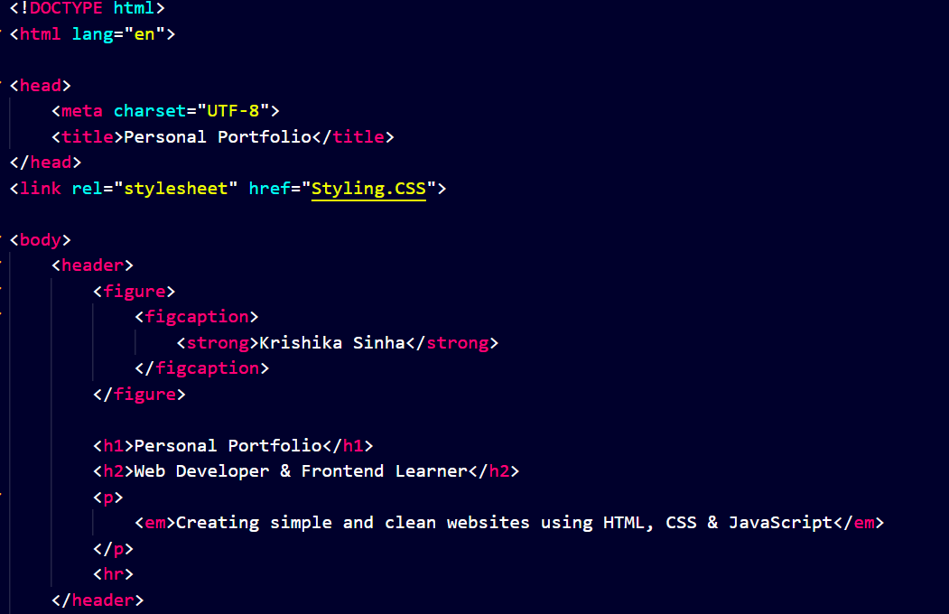
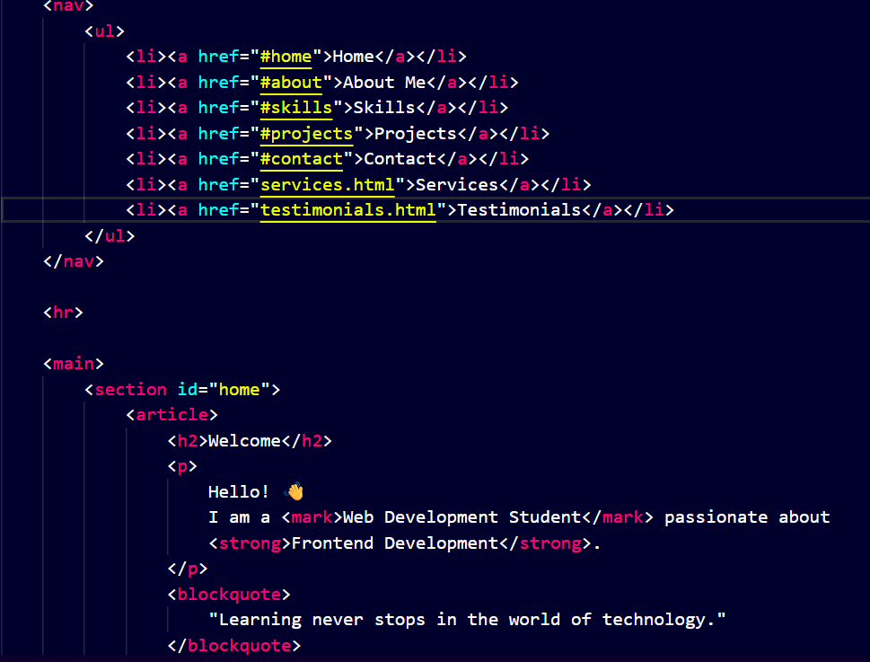
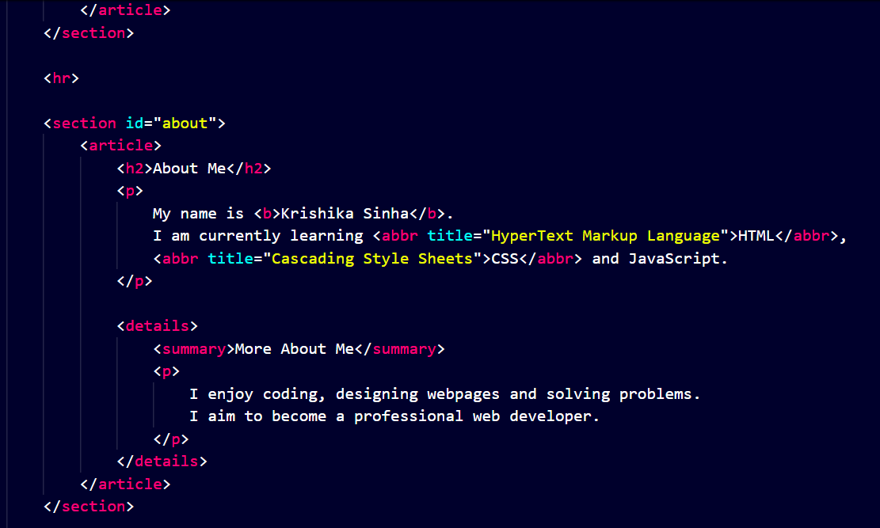
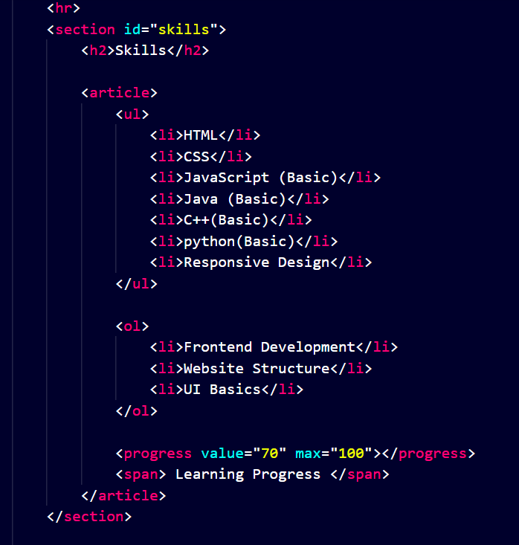
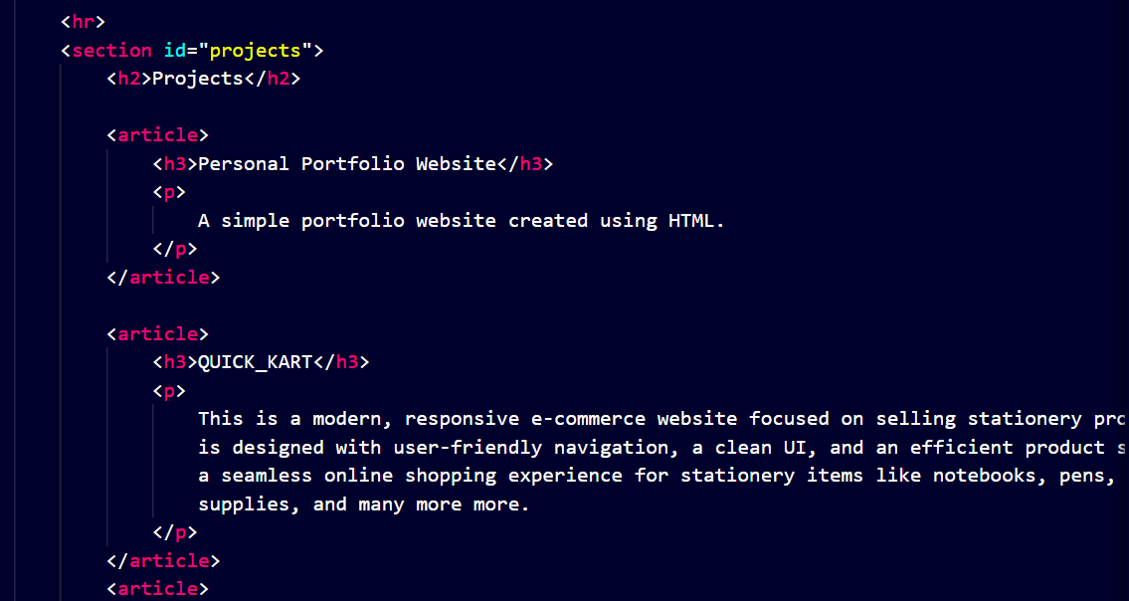
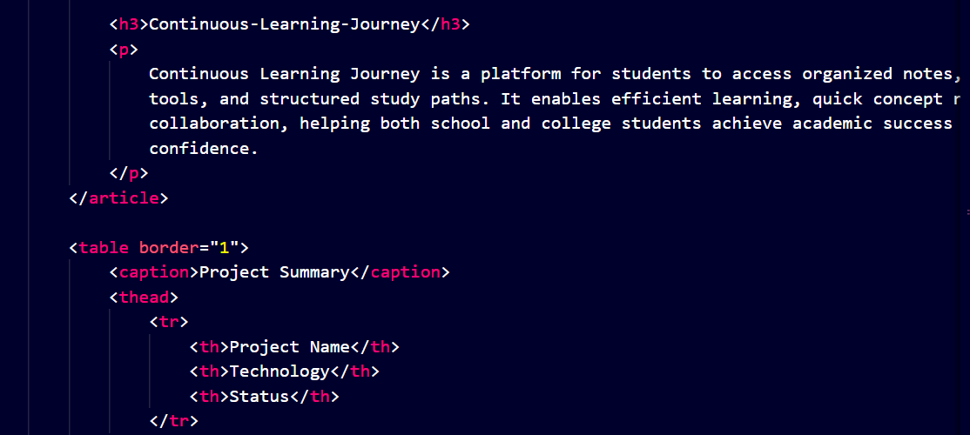
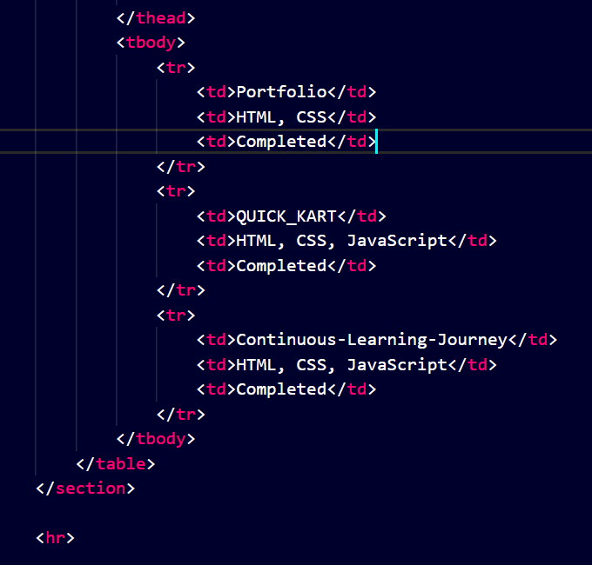
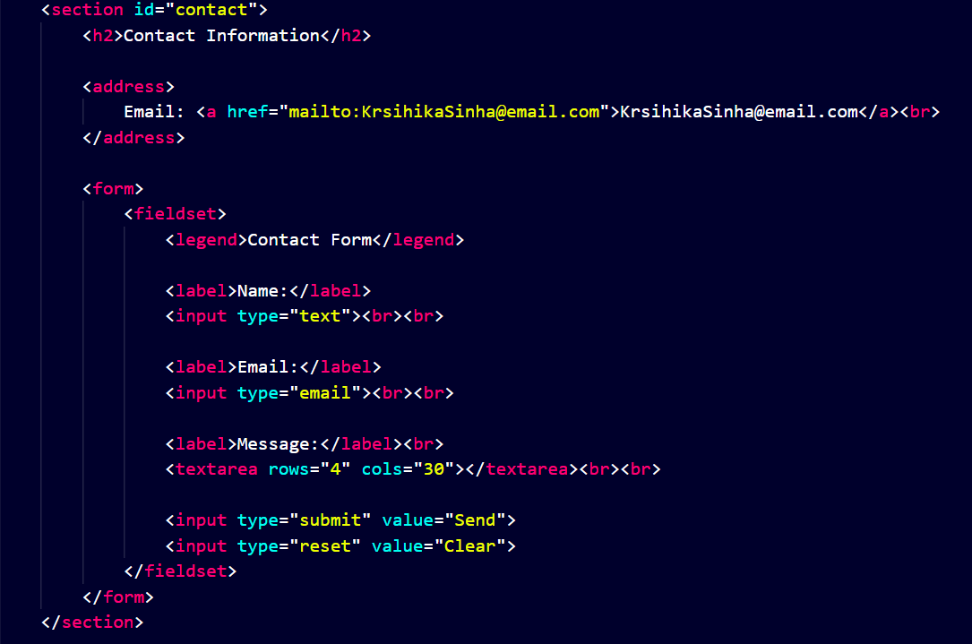
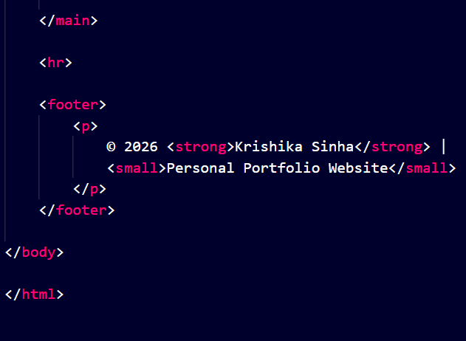
- CSS CODE :
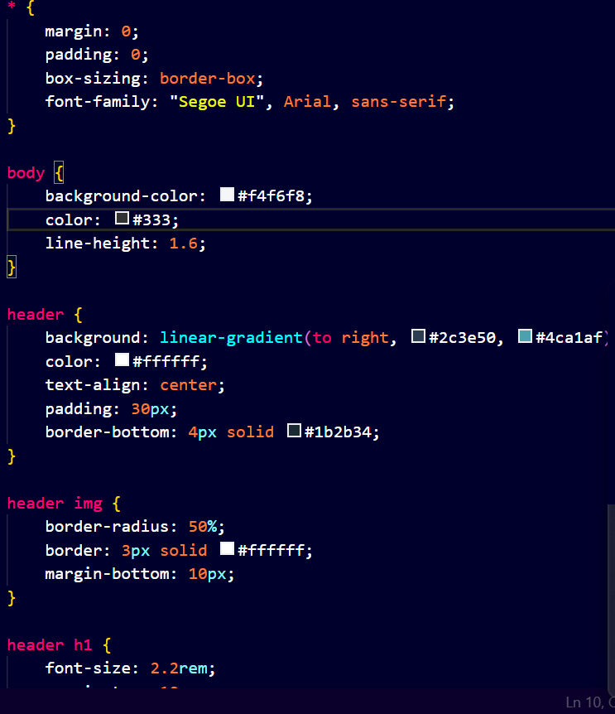
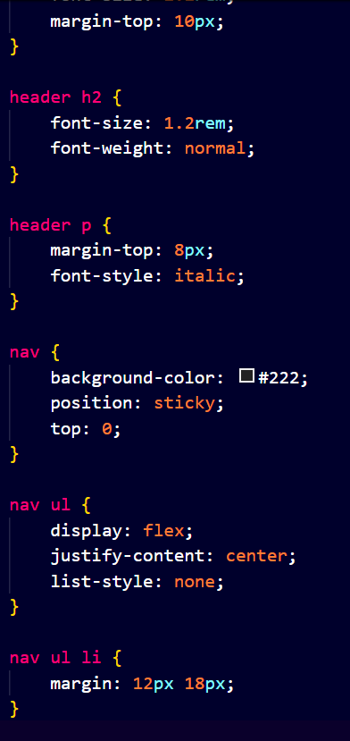
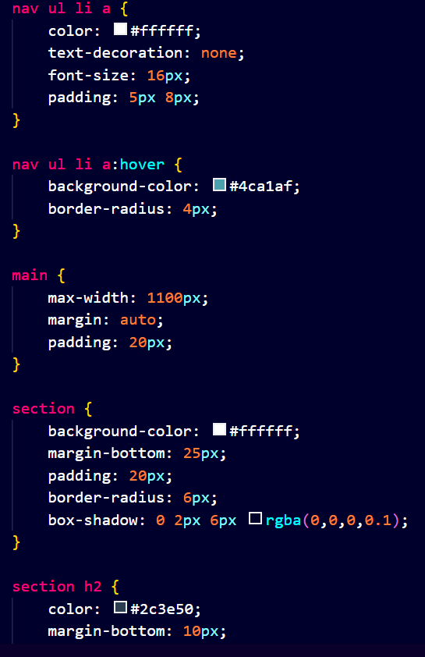
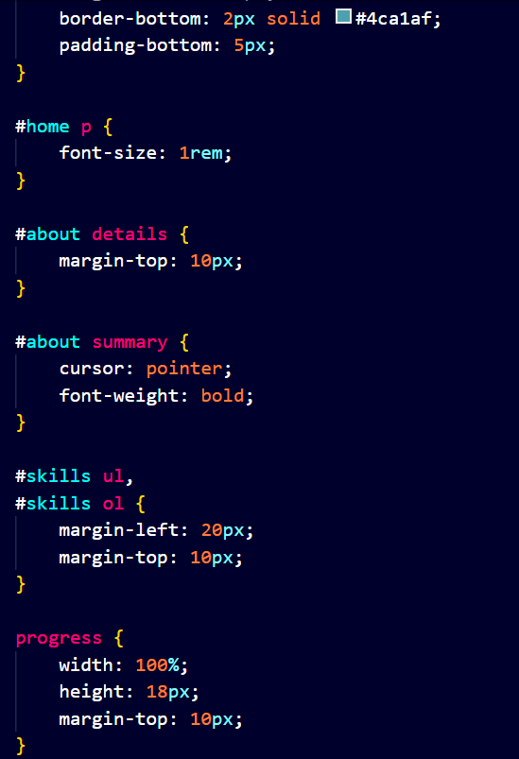
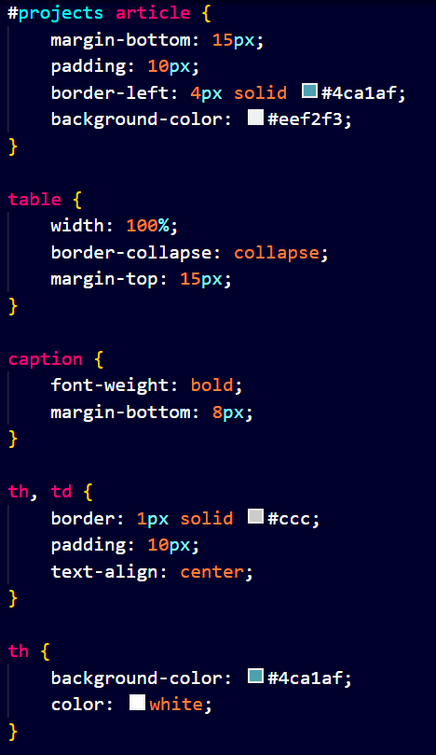
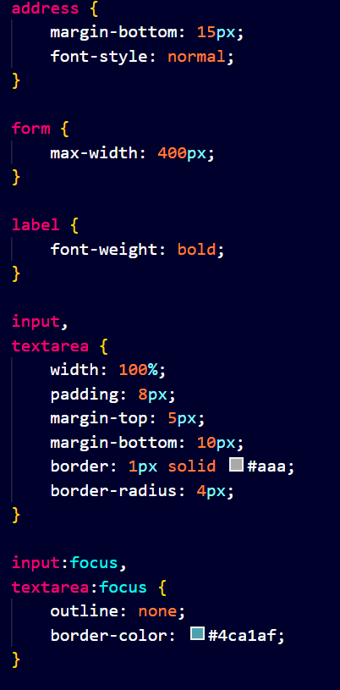
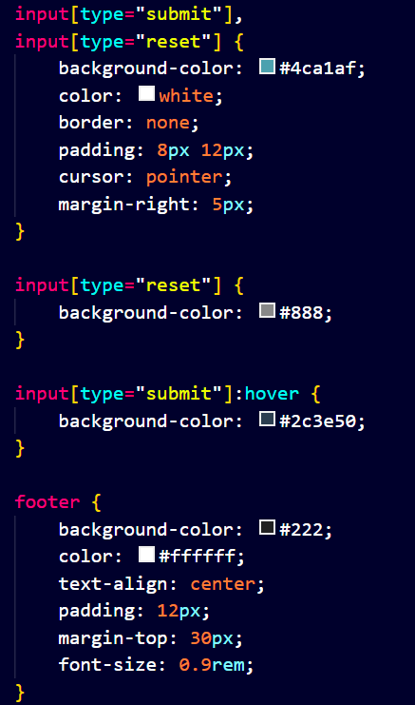
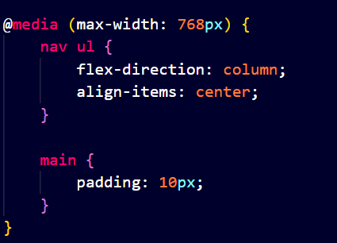
- JAVA SCRIPT CODE :

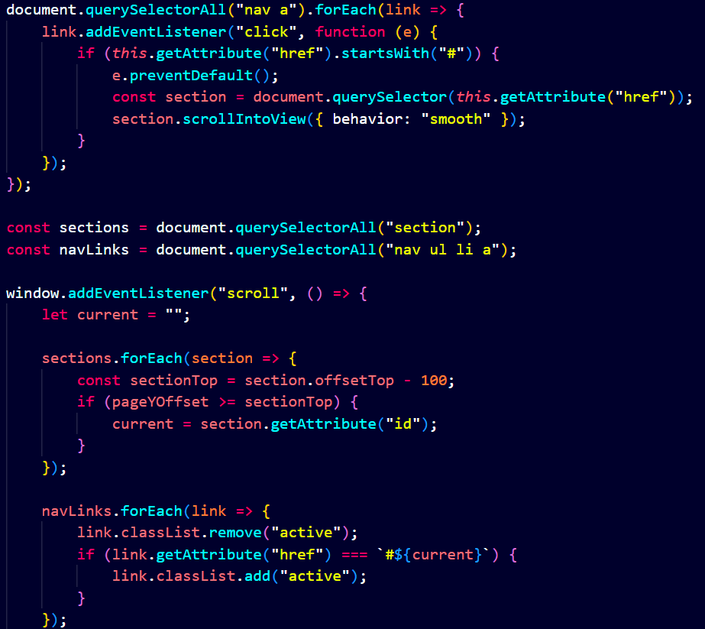
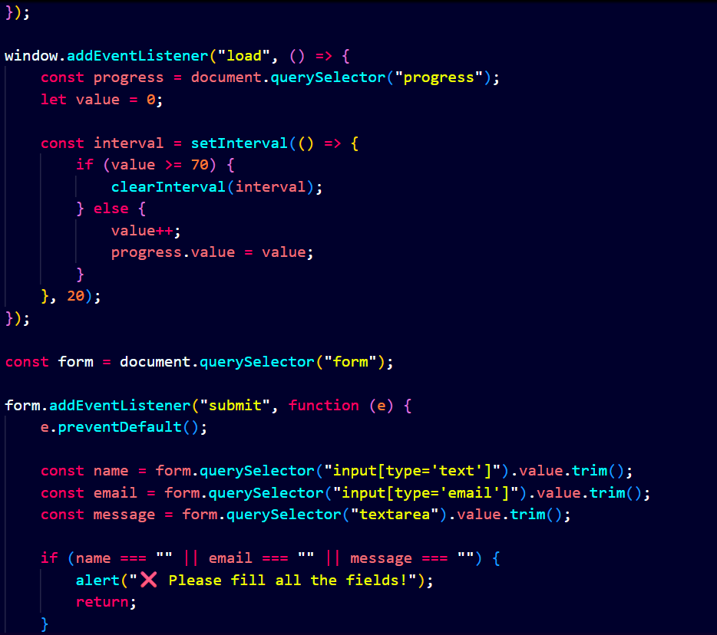
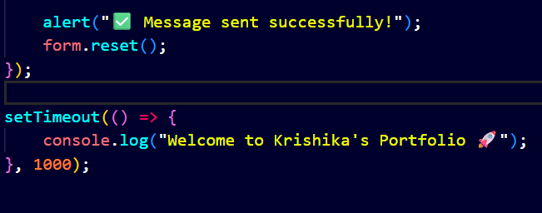

Output:

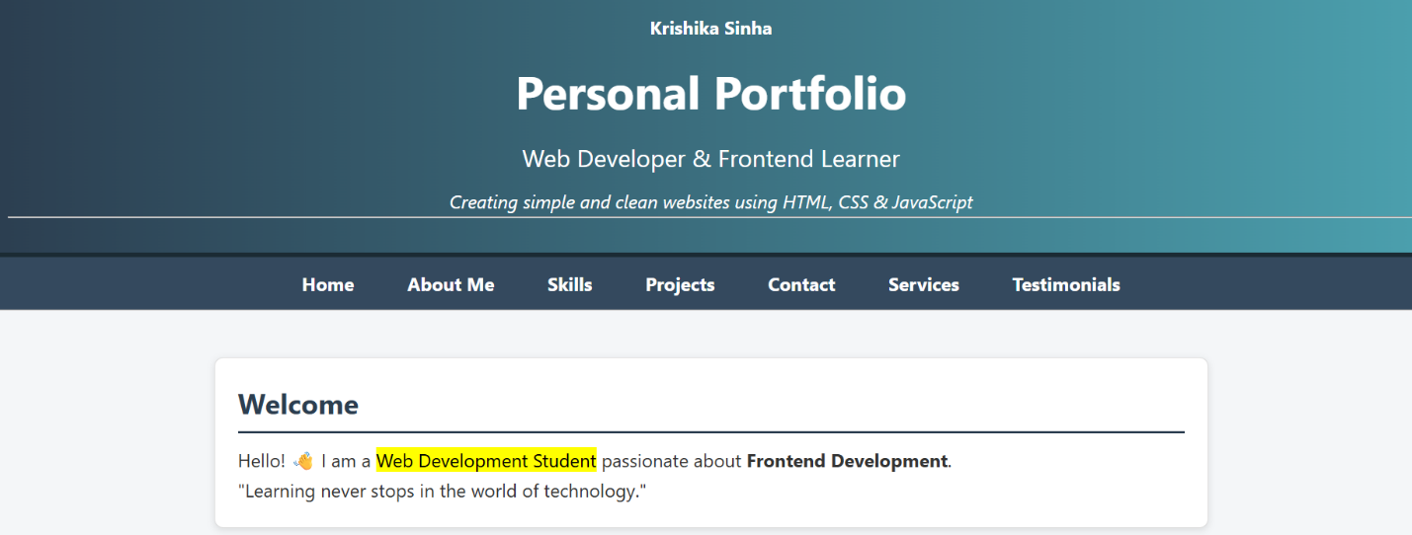
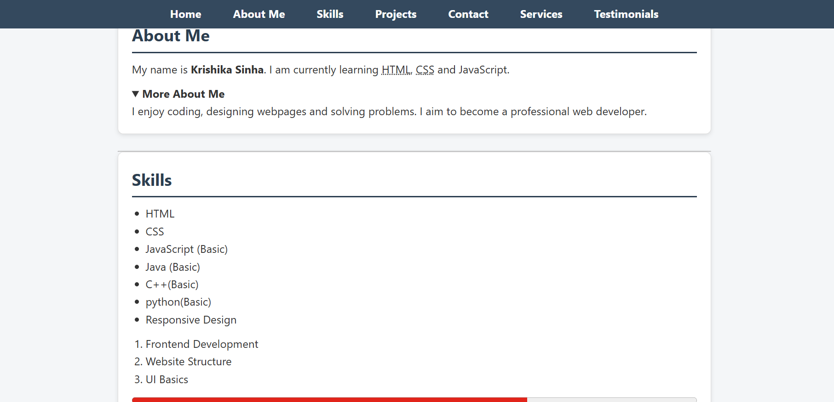
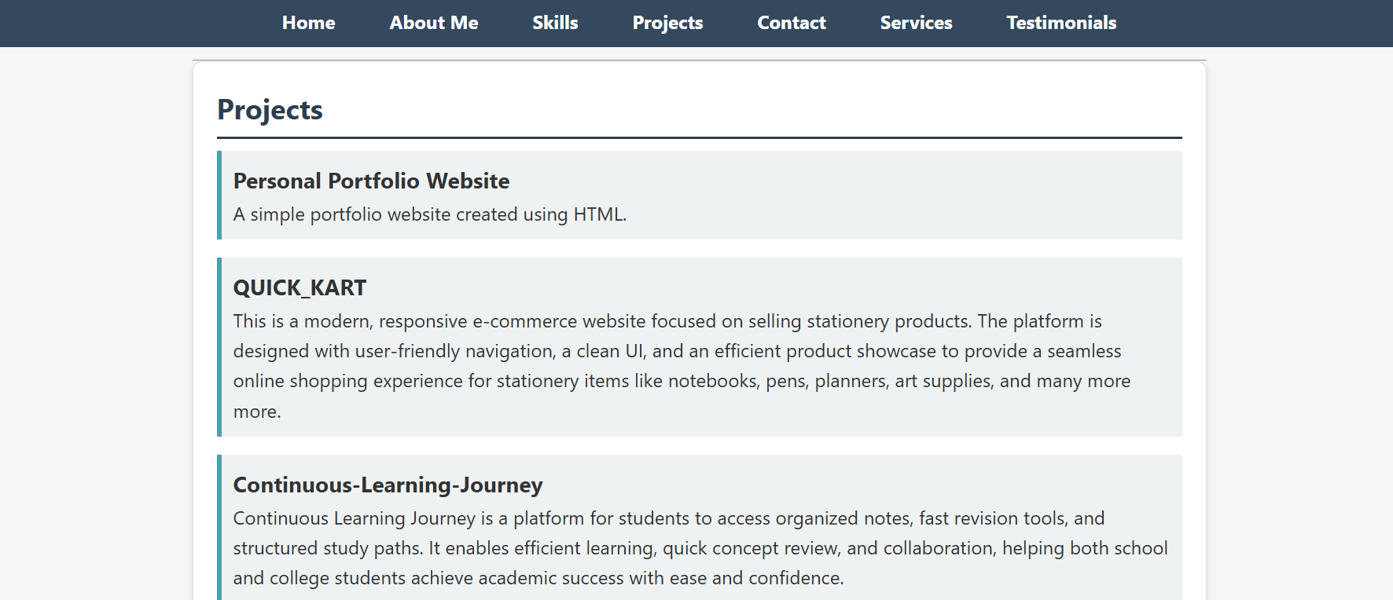

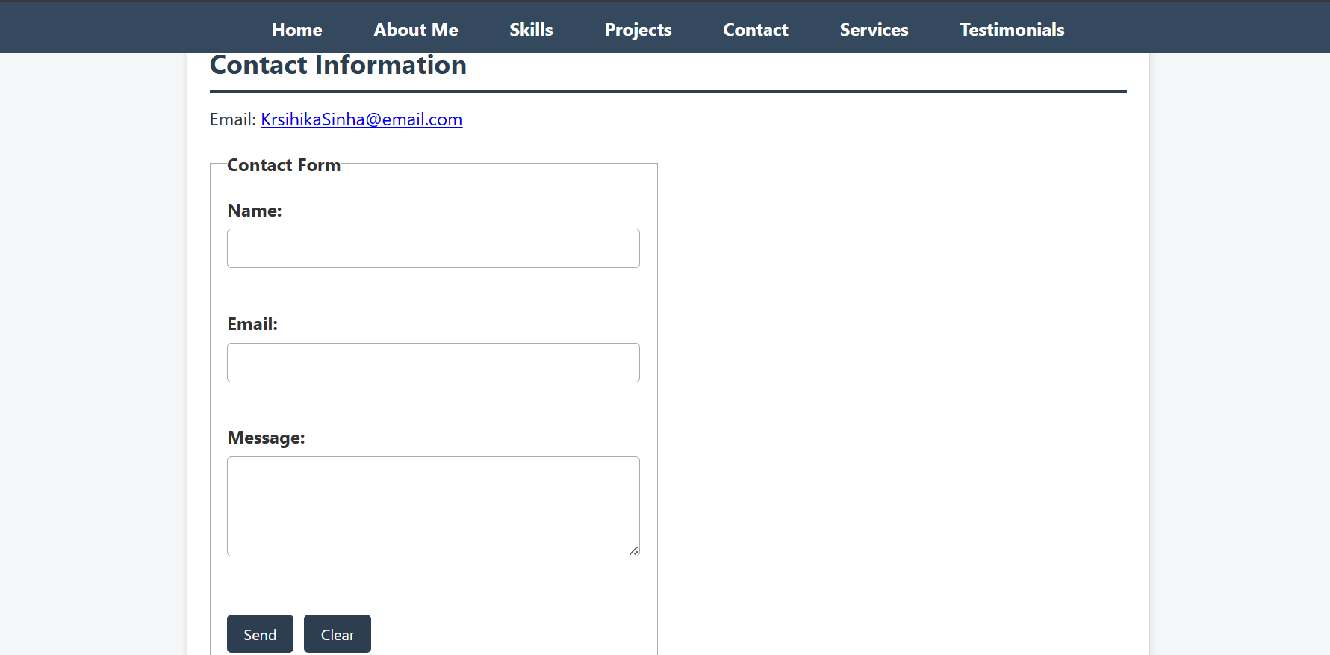

EXPERIMENT - 2

Aim:

Create a project folder named company_landing_page with HTML and CSS Styling

Tasks:
  - Project Setup & Introduction – Create a project folder named company_landing_page.
  - HTML Structure – Create the Services sections and Testimonials sections using semantic HTML.
  - Styling with CSS – Apply layout, colors, spacing, and neat design.
  - Projects & Skills Display – Show skills and projects clearly on the page.
  - Contact Form (Bonus) – Create a form with user submission feedback.

Tech Stack Used:
  - HTML and CSS

- CODES :
- HTML CODE :
- Services HTML:
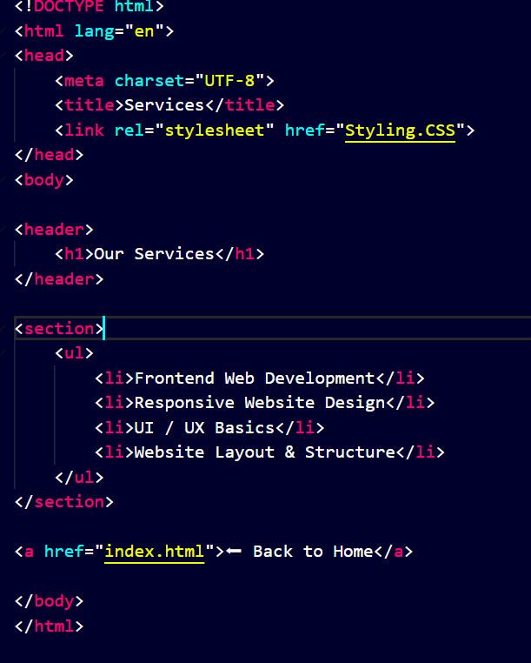
- Testimonials HTML

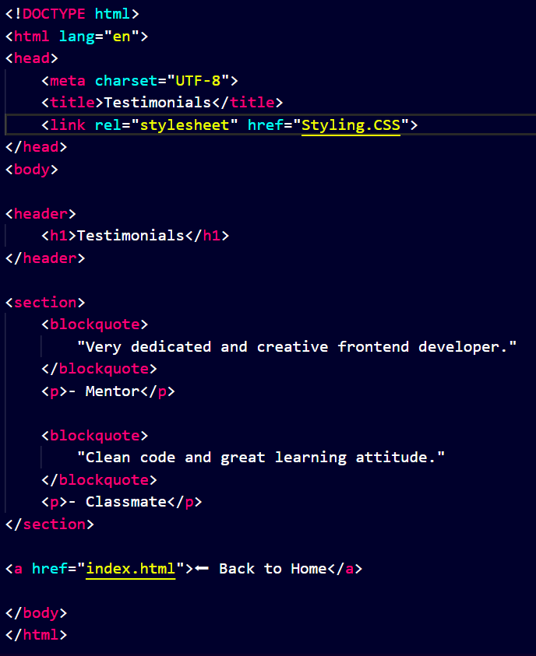
- CSS CODE :

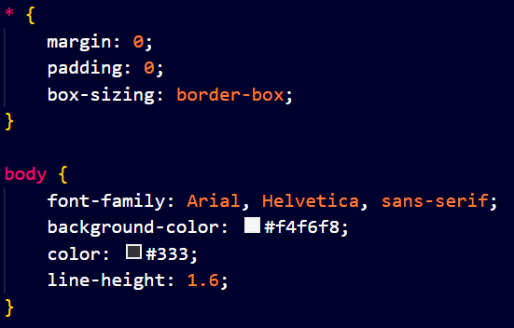
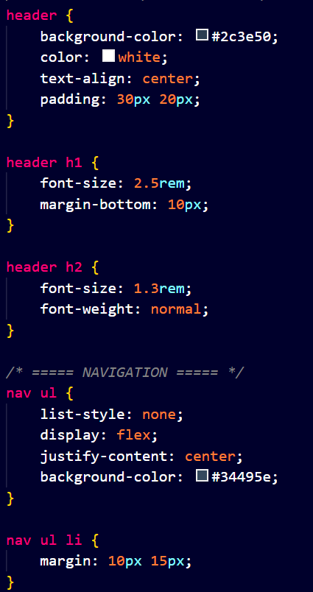
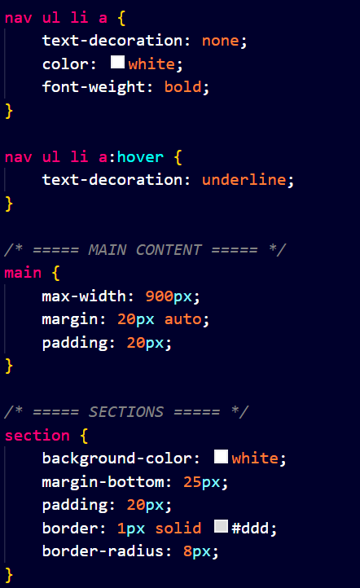
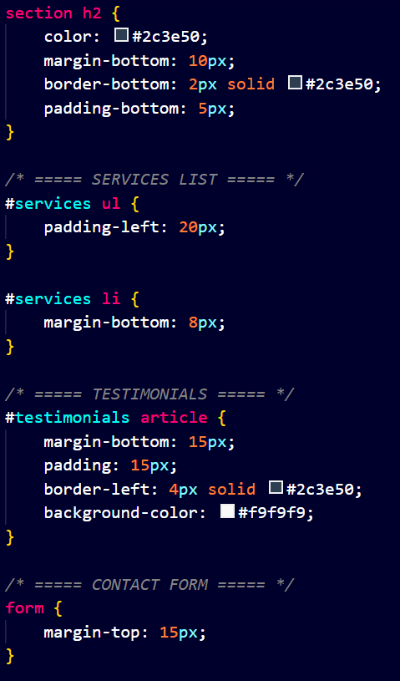
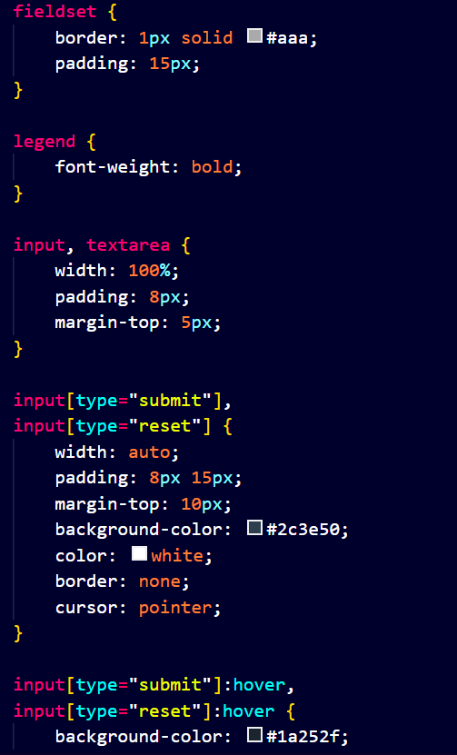
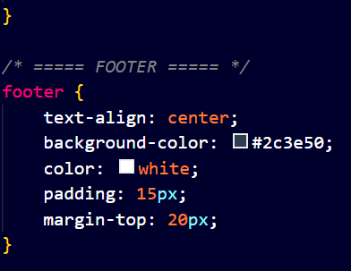

Output:
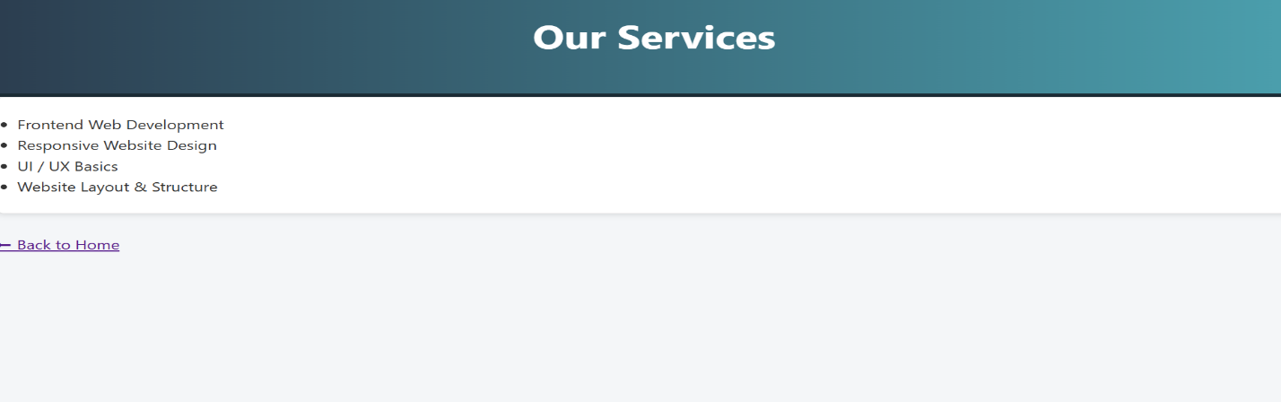
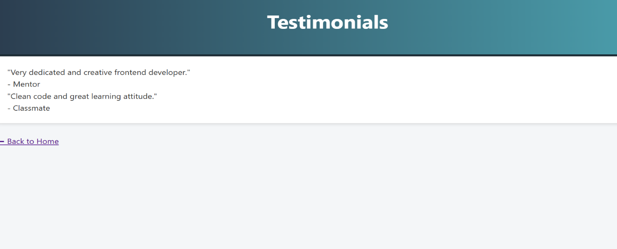

EXPERIMENT – 3

Aim:

Create a project folder named interactive_quiz with HTML, CSS Styling and JavaScript

Tasks:
  - Project Setup & Introduction – Create a quiz layout containing: Question text Multiple-choice options “Next” or “Submit” button Use semantic HTML elements for clarity.
  - Styling with CSS – Apply layout, colors, spacing, and neat design.
  - Projects & Skills Display – Show skills and projects clearly on the page.
  - JavaScript Interactivity – Store quiz questions and answers in JavaScript

Tech Stack Used:
  - HTML, CSS and JavaScriipt

- CODES :
- HTML CODE :
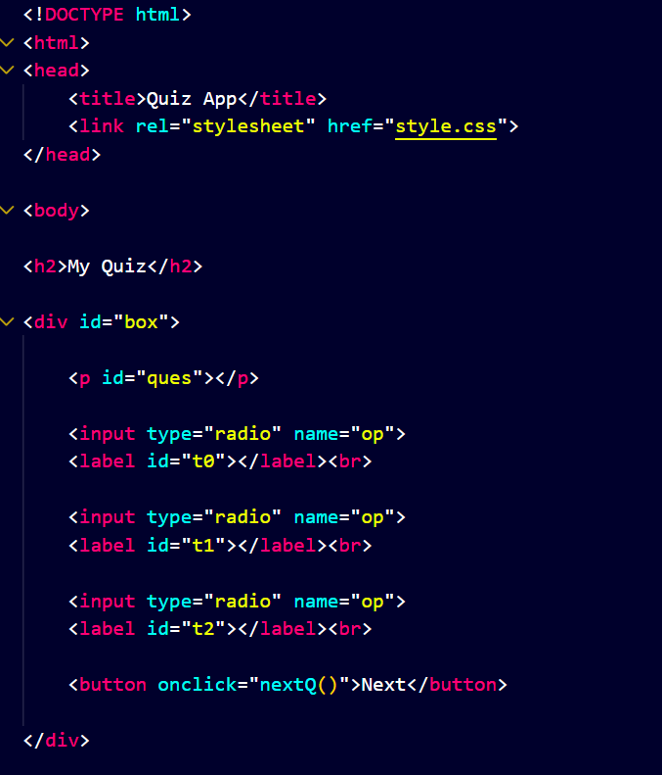
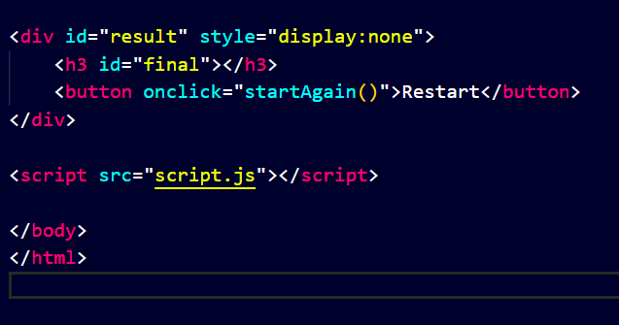
- CSS CODE :
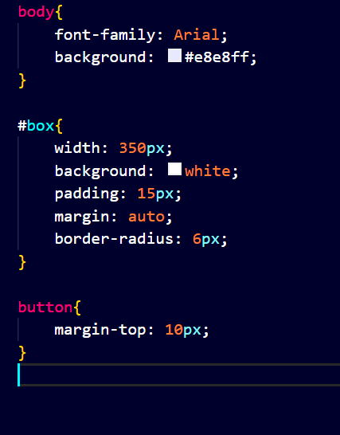

- JAVA SCRIPT CODE :
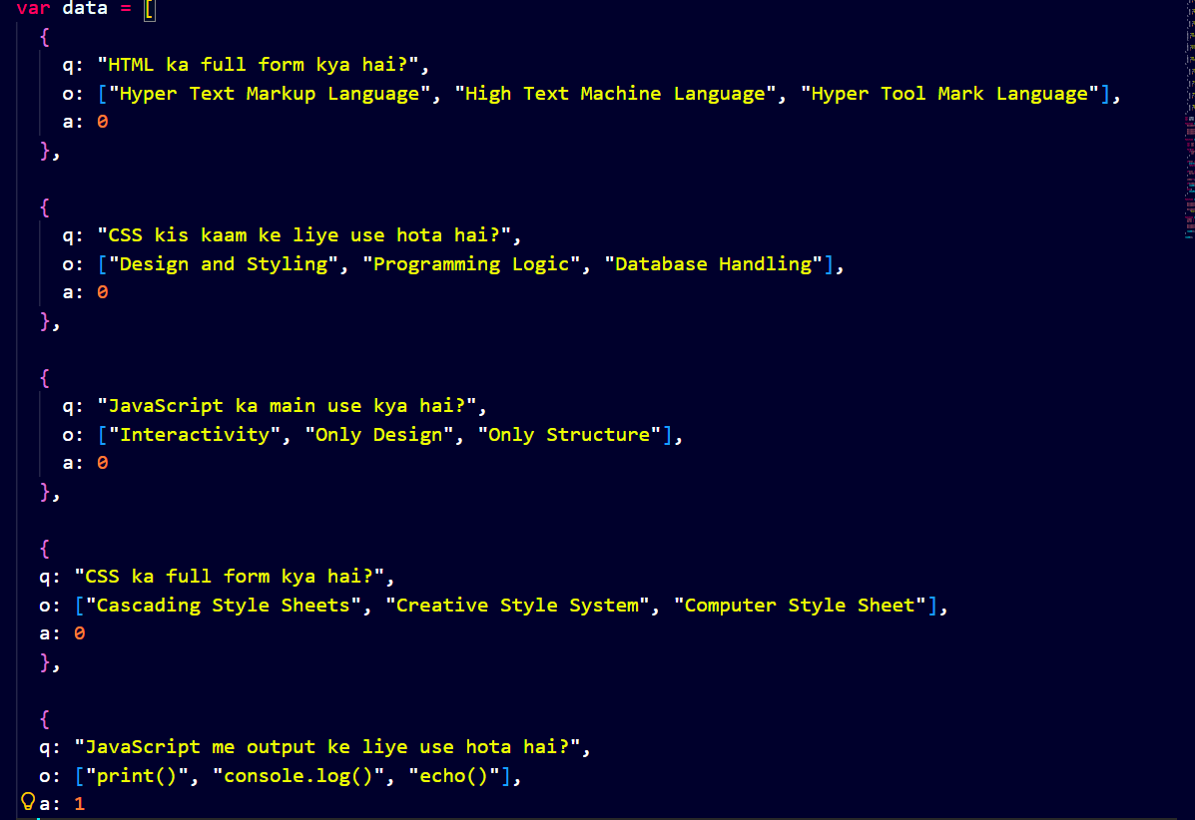
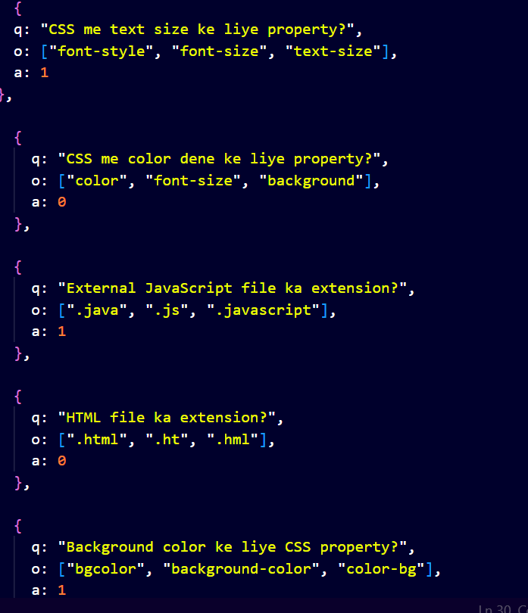
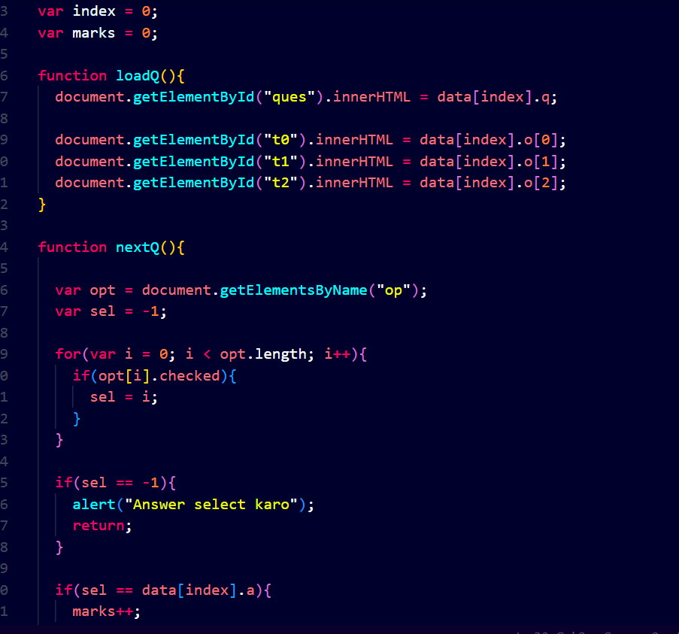
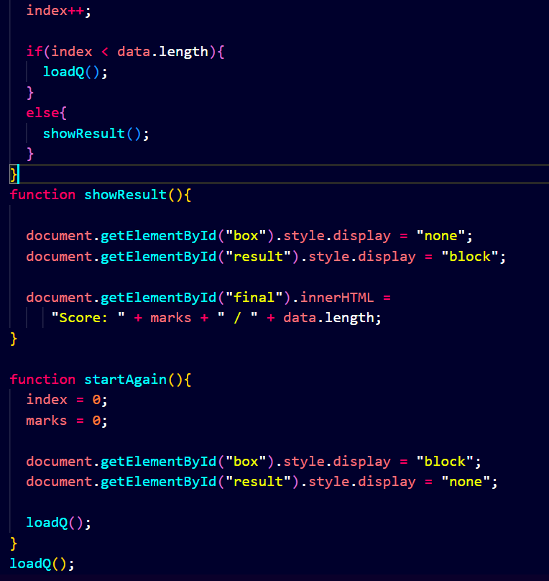
Output:

